♀19. Strength (Sexuality/Human Sexuality/Urges)—Track 23 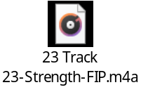

“I am the Potions Master at this school.”

